Contents Page

It’s ok to have only placeholder text.

PAGE TITLE

Page Subtitle

The Path of Heroes is a classless fantasy roleplaying game based off of Dungeons and Dragons, mostly 5th edition. The game currently doesn’t aim to teach you the basics of roleplaying and being a DM. It supposes you already know how to play Dungeons and Dragons, Pathfinder, Fantasy Age or any other roleplaying game. What it will teach you is how to play this specific game and all you have to know to do combat, create your character and play it thematically and various other things and for the Dungeon Master - how to create encounters, how to reward the players, etc.

**1. Choose a Race (Title)**

The Path of Heroes aims to provide a set of combat and progression rules, with more linear power curves and more emphasis on items and gear (be they magic or not).

**Subtitle**

The core aspect of the game is that there are no specific classes to choose from.

**Subsubtitle**

when creating your character, but your character will gain abilities, skills and talents as they progress through the world created by the Dungeon Master in a fashion so that it makes sense regarding the personality, background and starting powers of your character.

Here is a table:

Level Prof Bonus T. Pts Total T. Pts

1 1 +4 4

2 1 +4 8

3 1 +4 12

4 2 +4 16

5 2 +4 20

6 2 +4 24

7 2 +5 31

8 3 +5 36

Here are some spells (should be standard size)

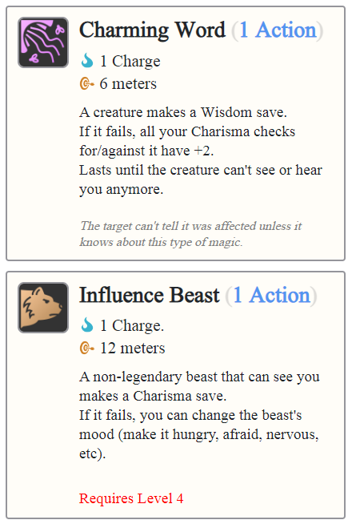

Monster Name…………………

Type: Beast

Degree: Normal

Experience: 250 XP

This is a monster description. This short-ish description will fit here.

Health: 28

Defense: 4

Speed: 5 meters

Initiative: 10

Stats:

MGT (4) DEX (3) INT (2) WIS (0) CHA (1)

**Attack 1:** 1d12 Pierce

**Attack 2**: 1d8 Slash

If at least a 1 was rolled, also try to Stun the target against its Might.

**Strength in Numbers:** Every Goblin attack deals +1 Damage for each Goblin fighting in their squad.

So, even if a goblin is alone, it has +1.

When a Goblin dies or flees, it no longer counts as a fighting Goblin.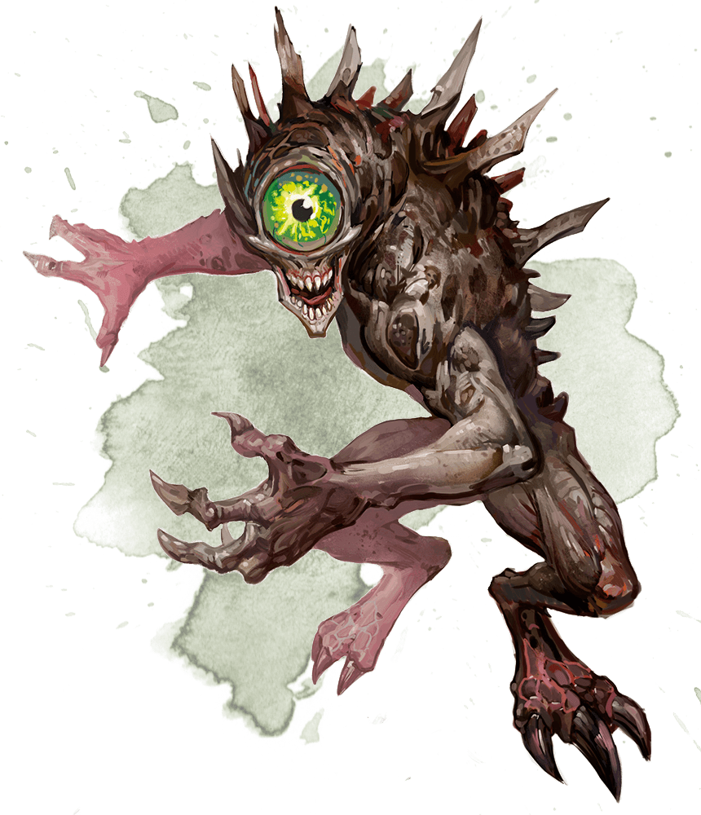

**Passive 2**: Immune to Slashing damage and Poison.

The monster description goes here.

Lorem ipsum dolor sit ament sidhe apxi xpex sichyeja osudai asi dao sik daskdh 8a sd sdia aoiw qxksdj sk aioush. Lorem ipsum dolor sit ament sidhe apxi xpex sichyeja osudai asi dao sik daskdh 8a sd sdia aoiw qxksdj sk aioush.Lorem ipsum dolor sit ament sidhe apxi xpex sichyeja osudai asi dao sik daskdh 8a sd sdia aoiw qxksdj sk aioush.Lorem ipsum dolor sit ament sidhe apxi xpex sichyeja osudai asi dao sik daskdh 8a sd sdia aoiw qxksdj sk aioush.Lorem ipsum dolor sit ament sidhe apxi xpex sichyeja osudai asi dao sik daskdh 8a sd sdia aoiw qxksdj sk aioush.Lorem ipsum dolor sit ament sidhe apxi xpex sichyeja osudai asi dao sik daskdh 8a sd sdia aoiw qxksdj sk aioush.Lorem ipsum dolor sit ament sidhe apxi xpex sichyeja osudai asi dao sik daskdh 8a sd sdia aoiw qxksdj sk aioush.